**DBMS LAB PROJECT**

**KEY MILESTONE # 01**

 **Spring 2025**

**CSE-403L**

**Database Management System Lab**

Submitted by:

**Mujahid Zada = 22PWCSE2145**

**Hashir Islam = 22PWCSE2192**

**Muhammad Haris = 22PWCSE2216**

**Muhammad Adnan = 22PWCSE2208**

Class Section: **‘B’**   
“Honesty is the Best Policy ”

Submitted to:

**Engr. Sumayyea Salahuddin**Sunday,25,2025

**Conceptual Schema for E-Commerce Platform**

# 1. Entity Description (Tabular Form)

|  |  |  |  |
| --- | --- | --- | --- |
| Entity | Attributes | Primary Key (PK) | Foreign Key (FK) |
| Customer | customer_id, first_name, last_name, email, password, address, phone_number | customer_id | - |
| Product | product_id, SKU, description, price, stock, category_id | product_id | category_id |
| Category | category_id, name | category_id | - |
| Order | order_id, order_date, total_price, customer_id | order_id | customer_id |
| Order_Item | order_item_id, order_id, product_id, quantity, price | order_item_id | order_id, product_id |
| Payment | payment_id, payment_date, payment_method, amount, customer_id | payment_id | customer_id |
| Shipment | shipment_id, shipment_date, address, city, state, country, zip_code, customer_id | shipment_id | customer_id |
| Cart | cart_id, quantity, customer_id | cart_id | customer_id |
| Wishlist | wishlist_id, customer_id | wishlist_id | customer_id |

# 2. Detailed Business Rules

1. Each customer must register with unique email and password.

2. A customer can place multiple orders, but each order belongs to only one customer.

3. An order can include multiple products, and a product can appear in many orders (many-to-many).

4. Each order must have one or more order items.

5. Each payment is linked to a single customer and order.

6. Products belong to specific categories, and each category can have many products.

7. Customers can maintain a cart and wishlist for multiple products.

8. Shipment details are linked to each customer’s order.

9. A product's stock quantity must be updated after an order is placed.

10. Each product must have a unique SKU.

# 3. Entity Relationship Diagram (ERD)

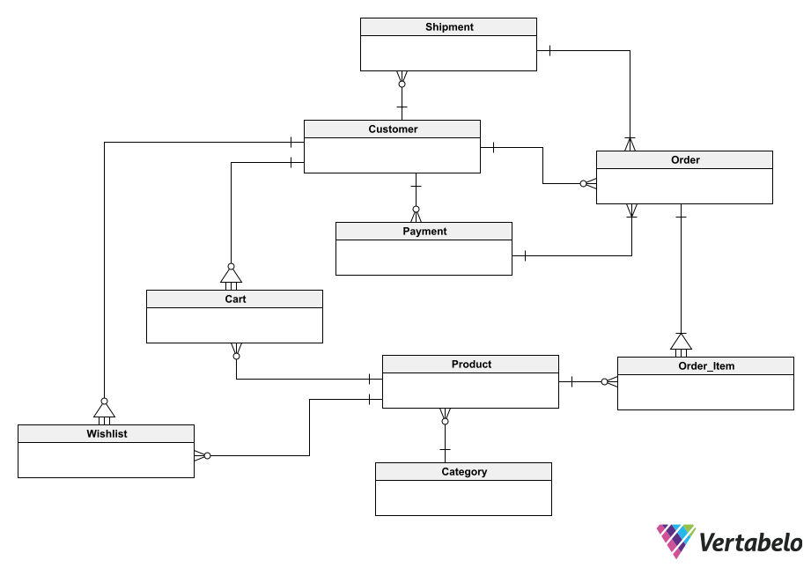

# 4. Enhanced Entity Relationship Diagram (EERD)

Enhanced ERD includes specialization/generalization, multivalued attributes, and more   
  
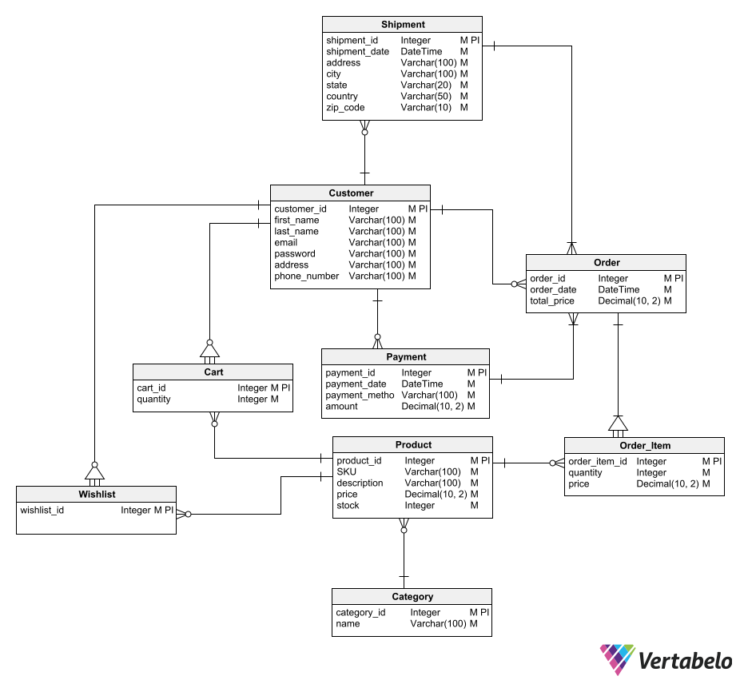

# 

# 5. References

1. ChatGPT by OpenAI (used for content creation and explanation)  
2. Vertabelo (used for ERD/EERD diagram creation) = https://vertabelo.com/blog/er-diagram-for-online-shop/  
3. Lecture Slides: Lecture 2b, Slide#3 and Slide#4  
4. W3Schools SQL and DBMS Tutorials  
5. draw.io (for diagram refinement )  
6. Course Materials and Class Notes